# PRACTICAL-11

**AIM**- To create a PL/SQL block that deletes records from a table with age 21.

Additionally, it generates a trigger that stores the original record in another table before deletion.

## Constraints

1. **Deletion Condition**: Delete records from the main table where the age is 21.
2. **Trigger**: Before deleting a record, store the original record in another table.

## QUERY:

CREATE TABLE Employees ( id NUMBER PRIMARY KEY, name VARCHAR2(50),

age NUMBER

);

CREATE TABLE DeletedRecords ( id NUMBER,

name VARCHAR2(50), age NUMBER, deleted_date DATE

);

INSERT INTO Employees (id, name, age) VALUES (101, 'Alice', 21); INSERT INTO Employees (id, name, age) VALUES (102, 'Bob', 25); INSERT INTO Employees (id, name, age) VALUES (103, 'Charlie', 21); INSERT INTO Employees (id, name, age) VALUES (104, 'Peter', 30);

CREATE OR REPLACE PROCEDURE delete_and_backup_employees ( p_age IN NUMBER

) AS BEGIN

INSERT INTO DeletedRecords (id, name, age, deleted_date) SELECT id, name, age, SYSDATE

FROM Employees WHERE age = p_age;

DELETE FROM Employees WHERE age = p_age; DBMS_OUTPUT.PUT_LINE('Records deleted and backed up: ' || SQL%ROWCOUNT);

EXCEPTION

WHEN OTHERS THEN

DBMS_OUTPUT.PUT_LINE('An error occurred: ' || SQLERRM); END;

BEGIN

delete_and_backup_employees(21); END;

SELECT * FROM Employees; SELECT * FROM DeletedRecords;

# Tasks -

**Test Case 1:** Delete records where the age is 21

**Objective**: Verify that records with an age of 21 are successfully deleted.

**Expected Result**: Records with an age of 21 ('Alice' and 'Charlie') should be deleted.

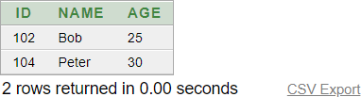

**Test Case 2**: Verify Trigger Functionality

**Objective**: Verify that the trigger successfully stores original records in the DeletedRecords table before

deletion.

**Expected Result:** The DeletedRecords table should contain the original records of 'Alice' and 'Charlie' before they were deleted.

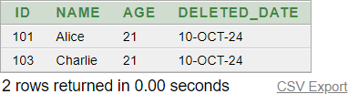

## CONCLUSION:

* From this practical I’ve learnt that how can I use SQL in a way that deleted data can be stored from one table to another table i.e. if user delete the data from a website/a software then it’ll automatically stored in main server/head-quarters so that one can reuse the deleted data.